**Design Class Diagram:**

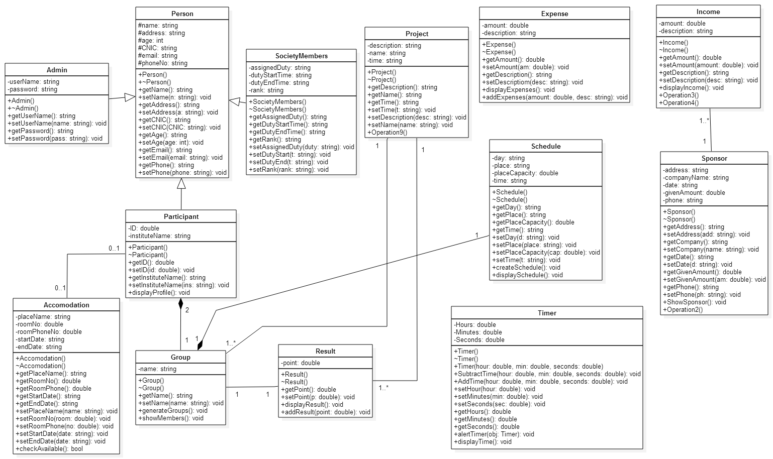

**Sequence Diagrams:**

Executive Login

# Admin and President can login to the system by providing the user name and password.

## Admin and President Try to login to the system by providing the wrong user name.

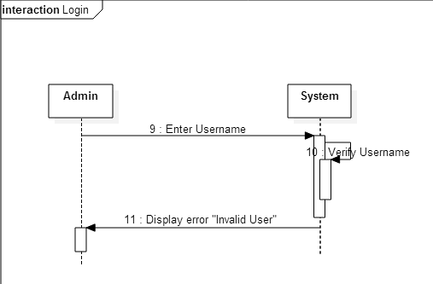

## Admin and President try to login to the system by providing the wrong password.

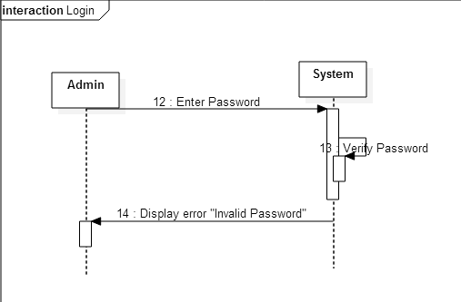

Register Participant

# It gets the all necessary bio-data about the participant to store their information.

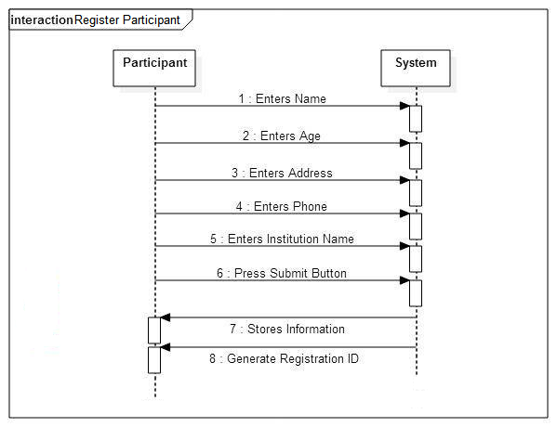

Remove Participant

# Un-register the participants from the competition and delete their all information stored in system

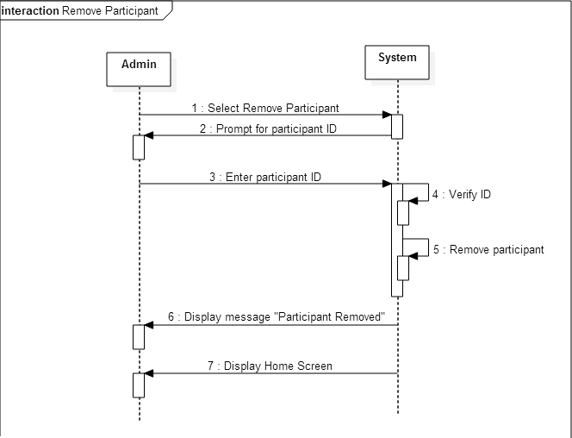

## Un-register the participants from the competition with wrong participant ID

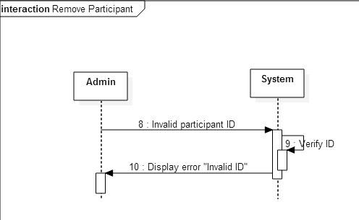

Add new Project

# The Admin can add the programming projects which will be assigned later on to the participants.

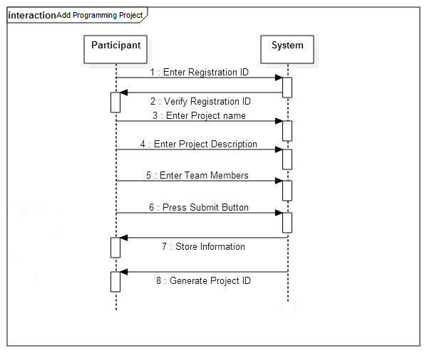

## When entered project name already exists in database.

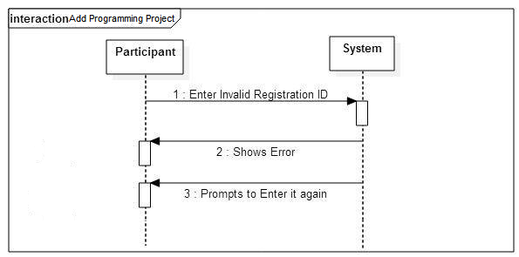

Manage Duties to members

# Add or change the duties to different Members of the organizing team

Participant Profile

# President or admin can view profile of the participants to see the personal information or the projects assigned to them

## If Admin enters invalid ID to view profile of participant

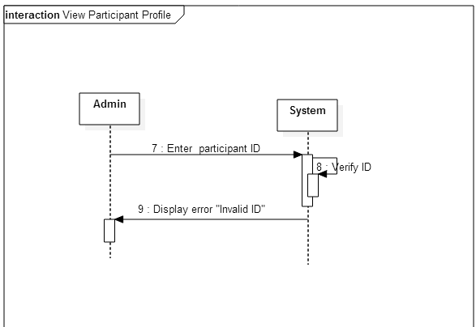

Create Groups

# Randomly create groups of participants to assign them projects later on in the competition

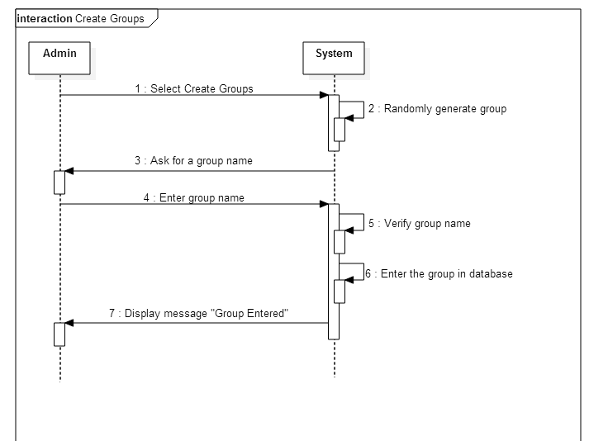

## When admin makes groups but group name already exists.

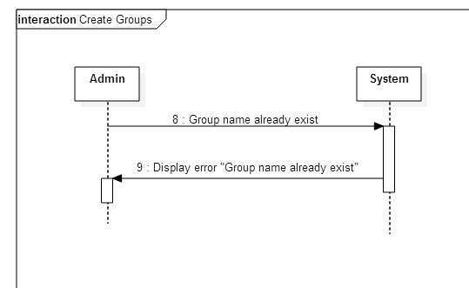

Assign Project

# All given projects are assigned to groups which are already created

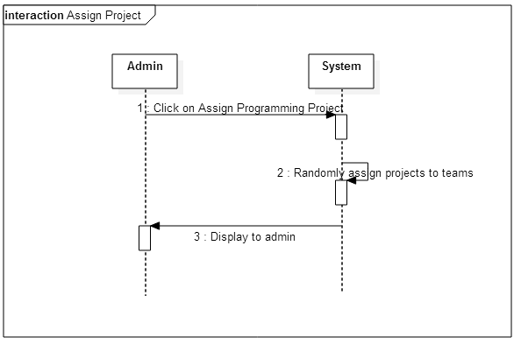

## If a project is already assigned then message is shown

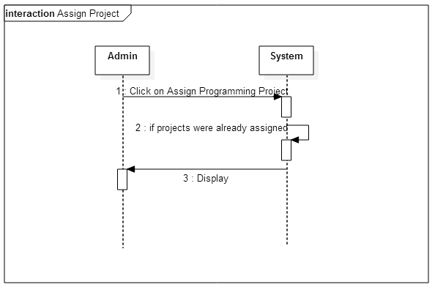

Creating Schedule

# Creates the competition schedule automatically

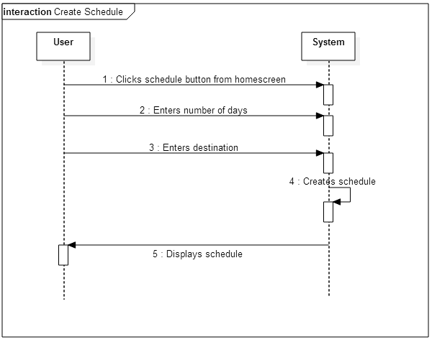

## When schedule is already made

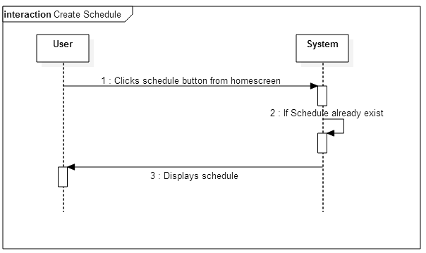

Competition Timer

# Timer Starts when user starts the competition.

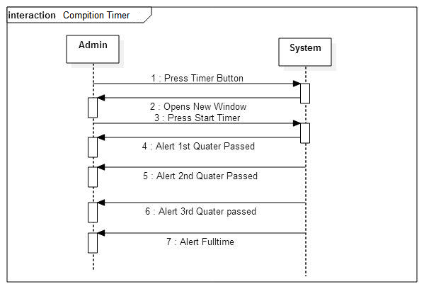

Competition time deduction

# Admin can deduct some time from total assigned time.

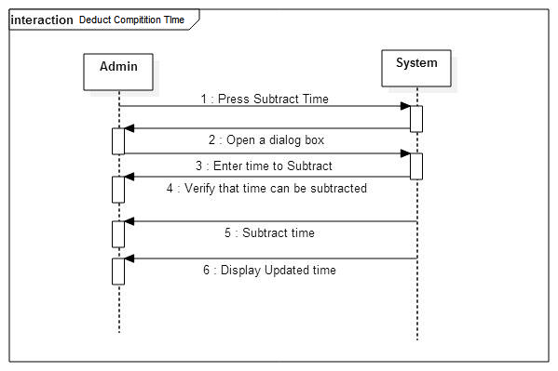

## If input time is more than remaining time to be deducted from.

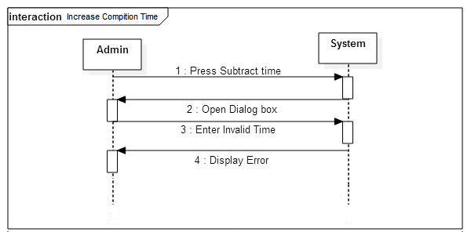

Admins Rights over already Assigned time

# Subtract time from assigned time.



## If time cannot be deducted then error is shown



Competition time addition

# Admin can add time to the already assigned time for competition

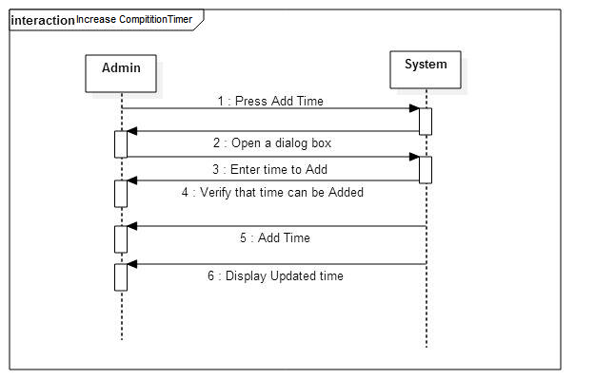

## When invalid time is added, error is shown

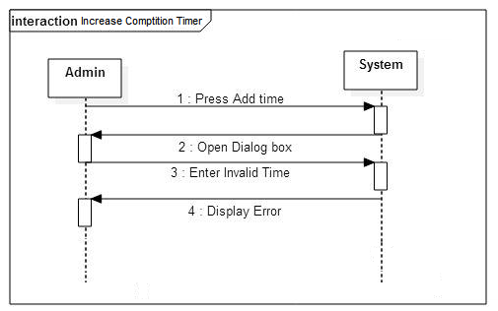

Manage accommodation

# All those participant who require accommodation will be assigned accommodation

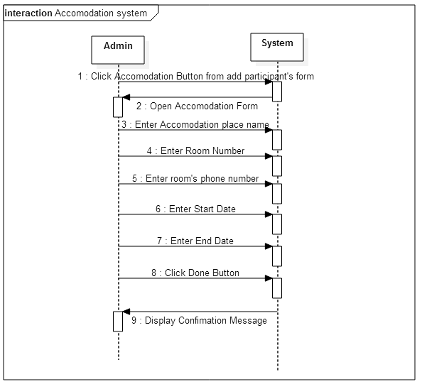

## When event start date is greater than ending date, error is shown

Deduct money from balance

# Budget management that keeps record of expenses, balance, income and sponsors

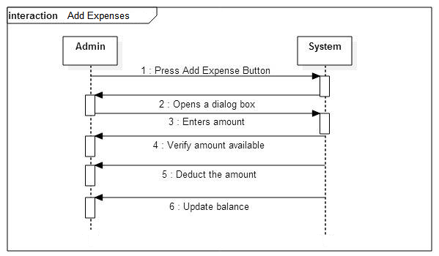

## When balance is less than amount deducted, error is shown

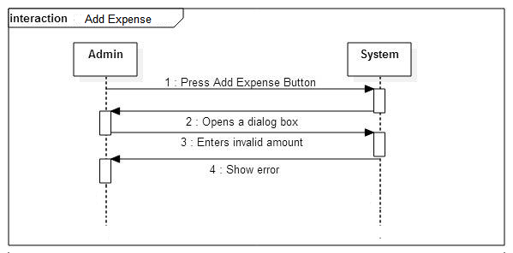

Add Money to balance

# Budget management income and sponsors details are stored

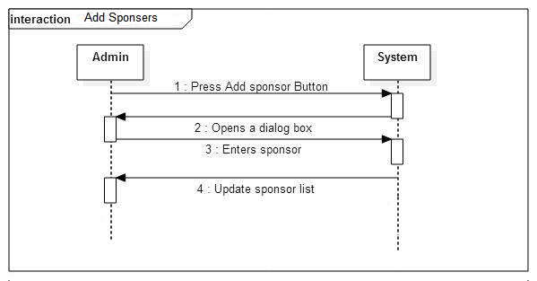

Net Balance

# Display records of expenses, and sponsor’s money

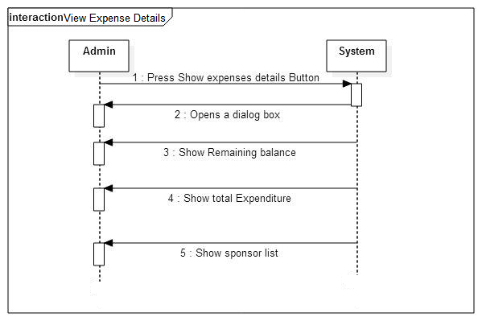

Competition Alert

# Alerts the user of their upcoming competition events

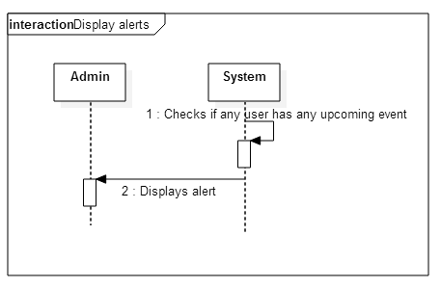

Log Out

# Log out from a profile.

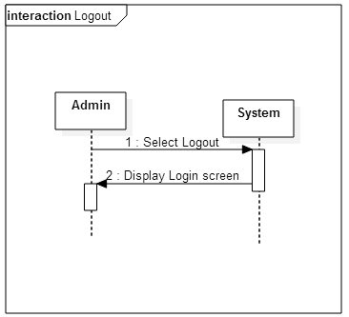

Add Result

# Compile participants final result

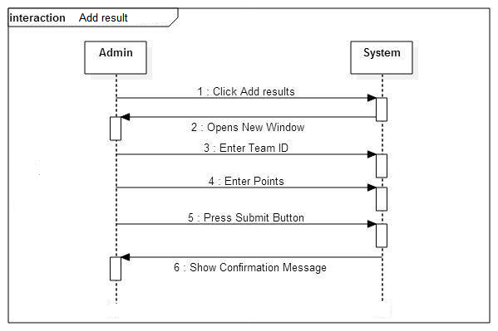

## When entered team id is wrong

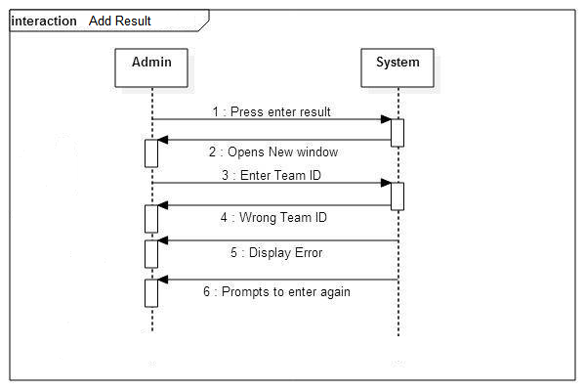

Display Result

# Display result card to print it

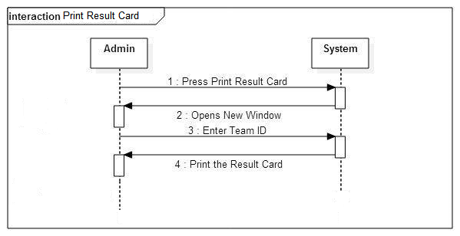

## When entered team id is wrong

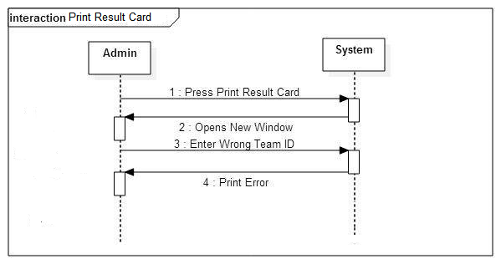

Display Result of groups

# Display result of groups to announce the winner

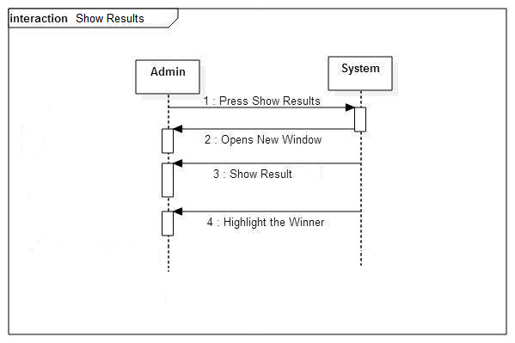

**Graphical User Interface(GUI):**

At start Admin should login:

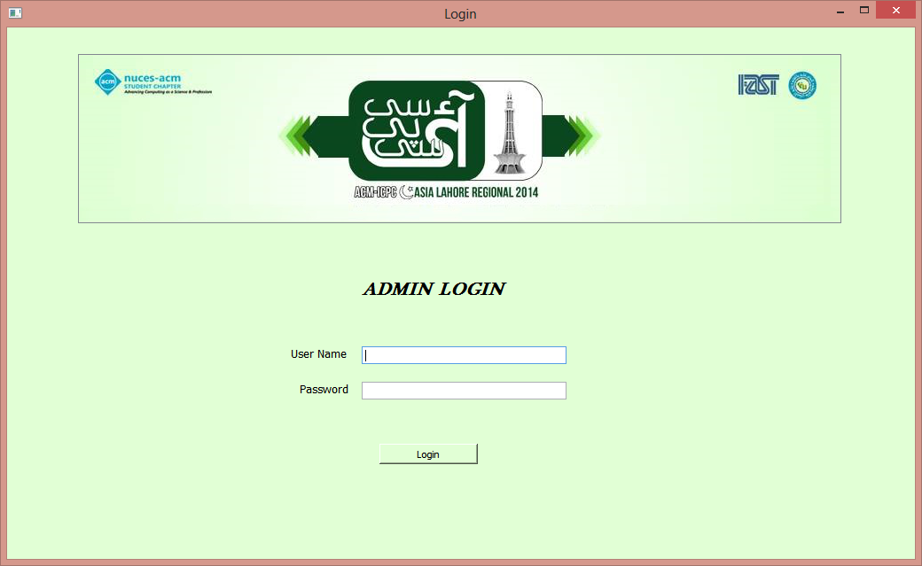

Error message:

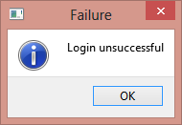

Confirmation message:

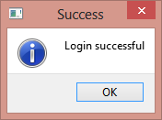

Home Screen:

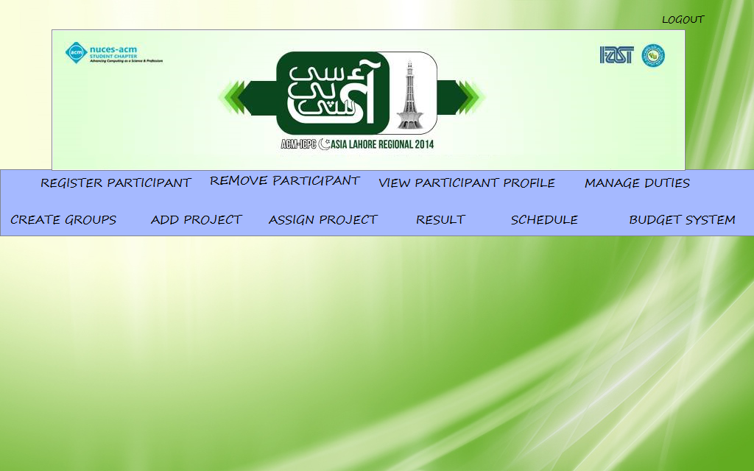

Click add participant from home screen to add participant.

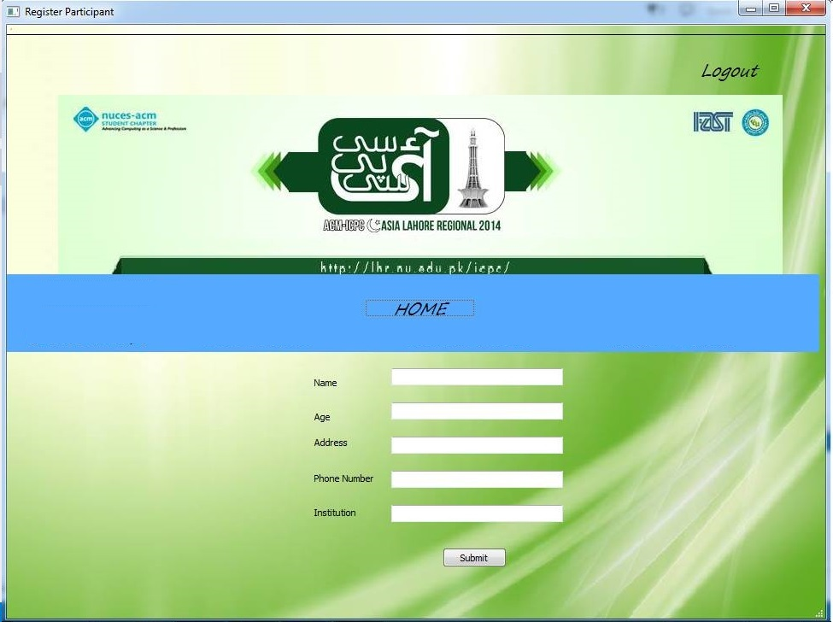

Confirmation message on adding participant.

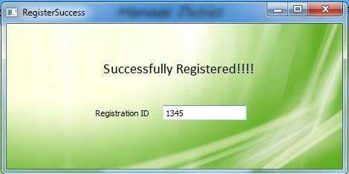

Mark check Box from add participant to add accommodation.

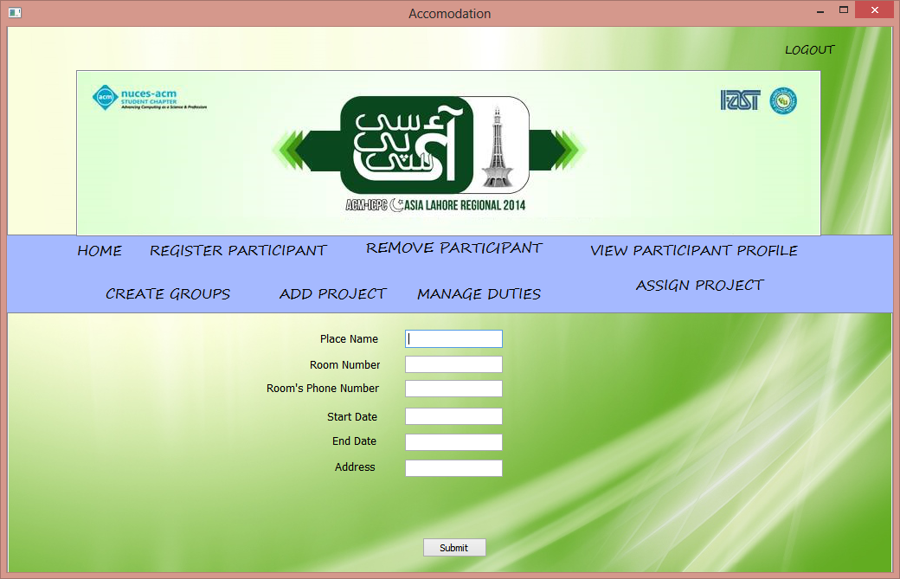

If start date is less than end date display error,

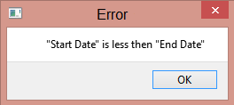

Display alerts before start of time.

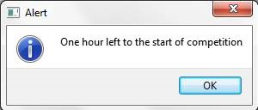

Start timer when competition start’s click button from home screen:

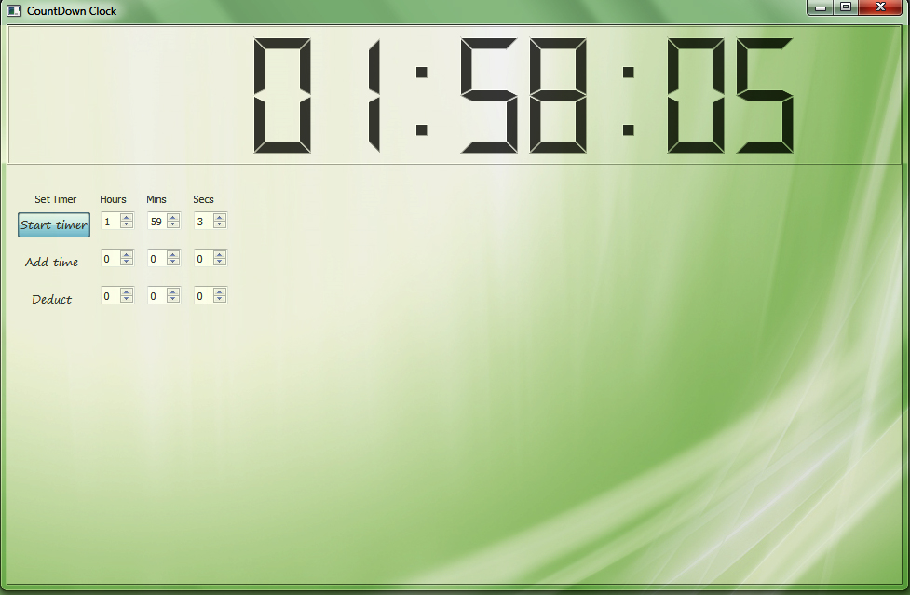

Add Time:

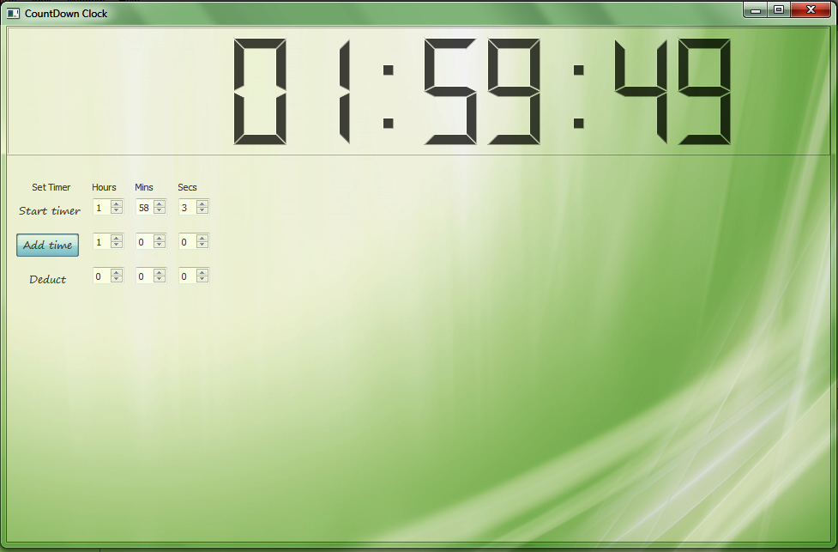

Deduct Time:

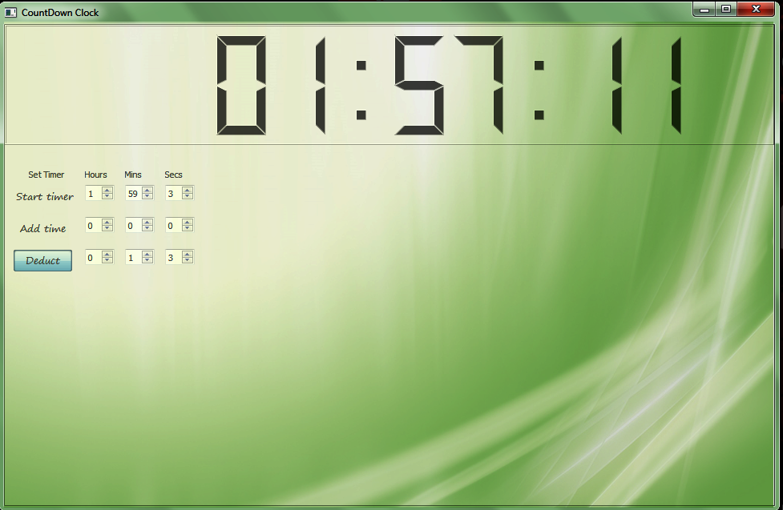

Assign Projects click button from Home screen:

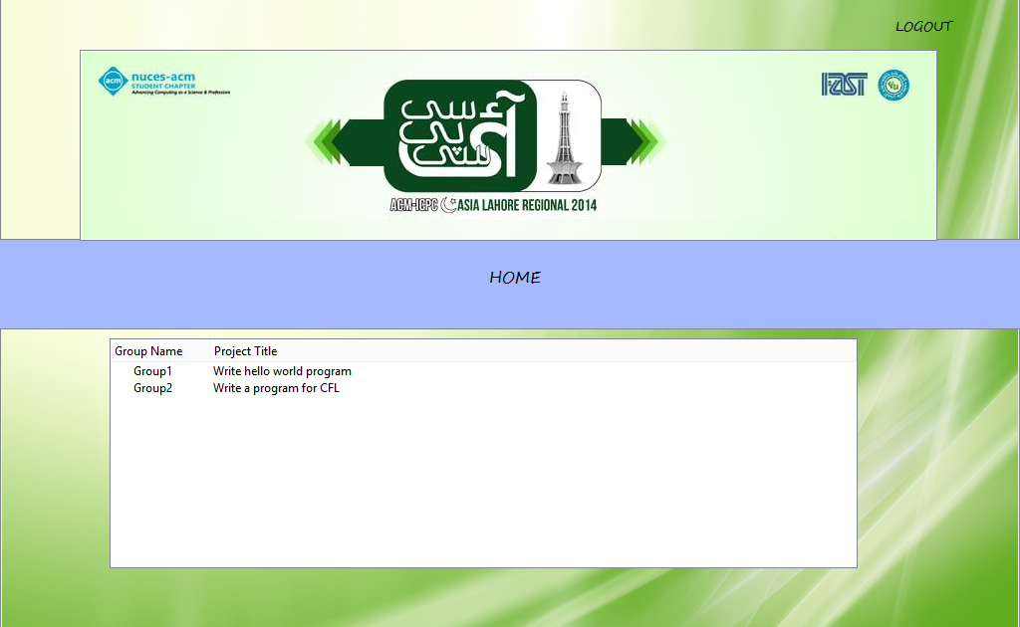

Click Budget from Home Screen and Click show expenses:

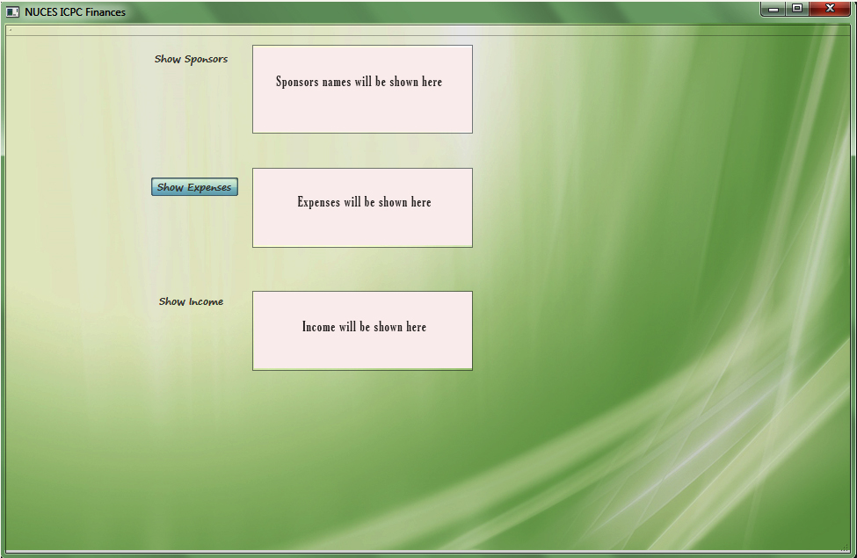

Click Show income:

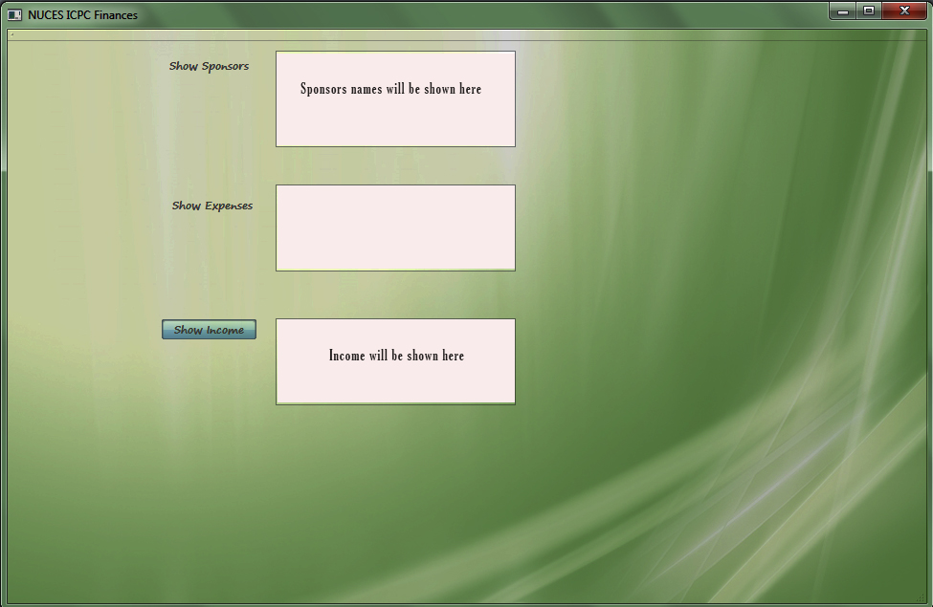

Click Show Sponsors:

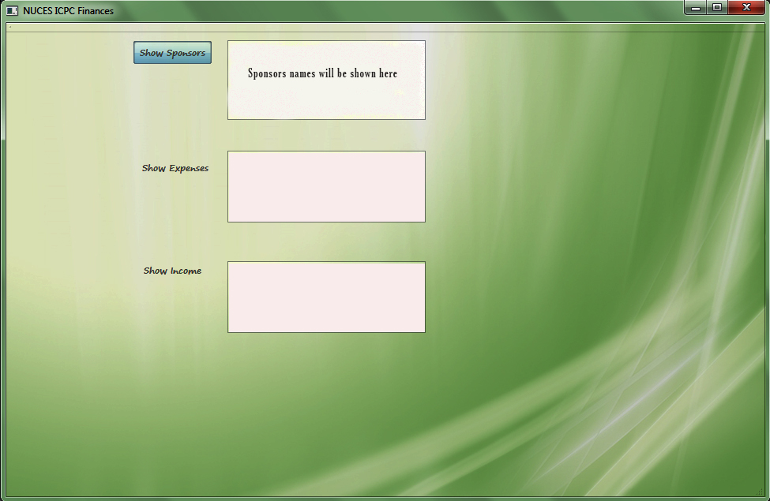

Over all details: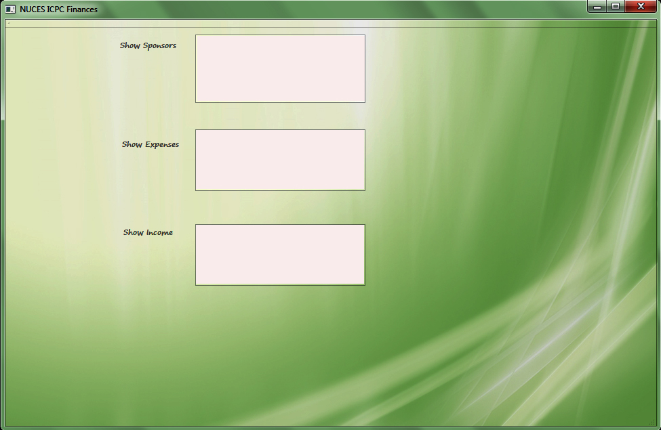

Add Projects by clicking on Home Screen:

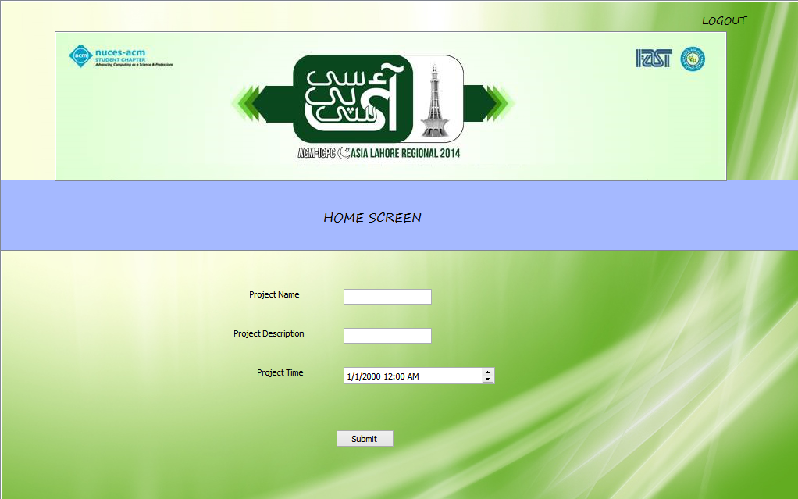

If Invalid project name display error:

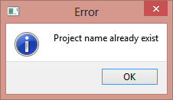

Confirmation Message:

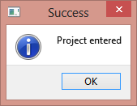

Click result from home screen tab view will open to display result, result card, add result:

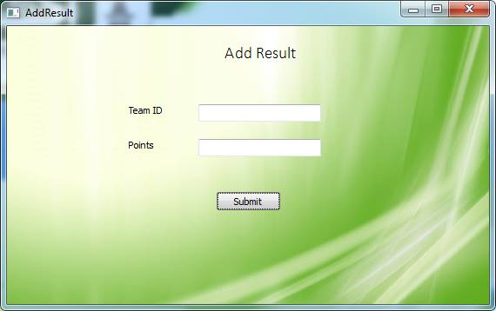

Print Result:

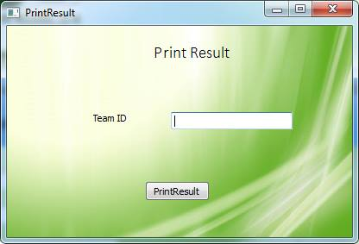

Click Schedule from Home Screen to display schedule:

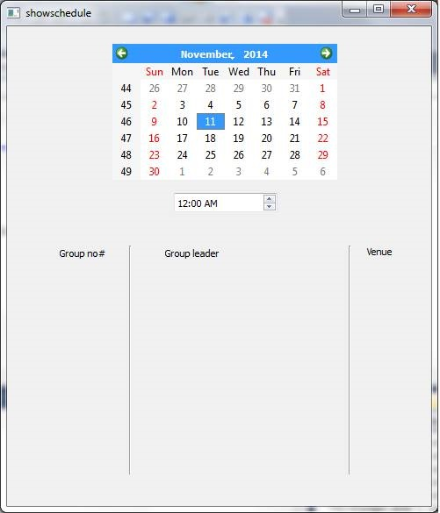

If schedule is not already created then ask for total number of days of competition:

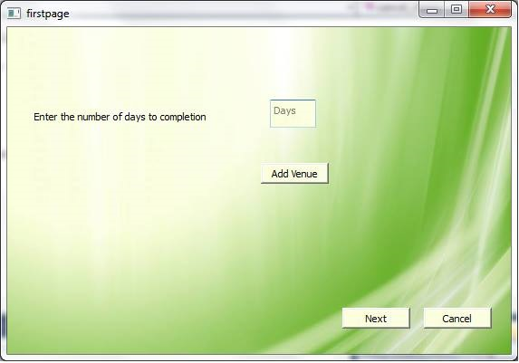

And also ask for venue to create schedule:

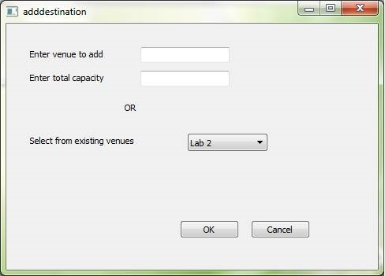

Click “Create Groups” to Create participants group:

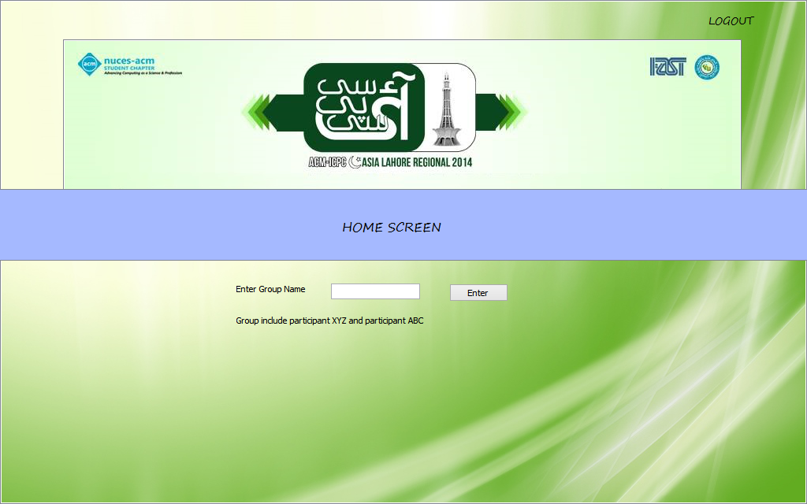

If group name already exist display error:

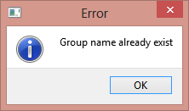

Confirmation message:

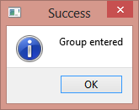

Click Manage duties from Home Screen:

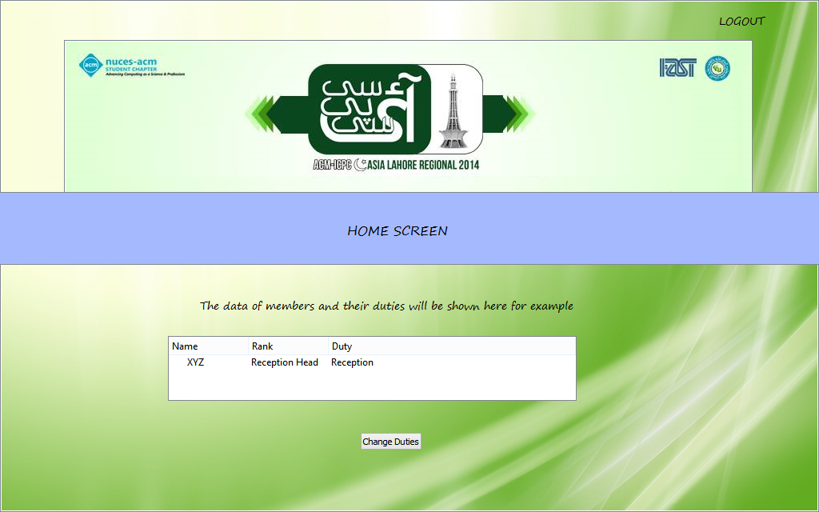

To remove participant Click remove participant from Home Screen:

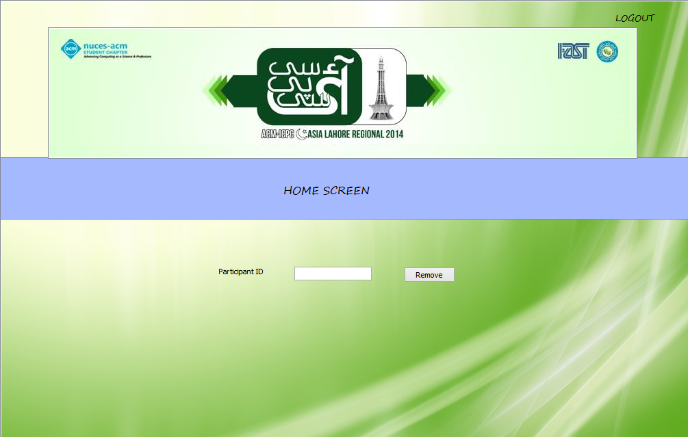

Error Message:

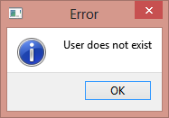

Success Message:

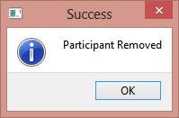

Click “Remove Participant” to remove:



Error Message:



Success Message:



Click View Profile from Home Screen:

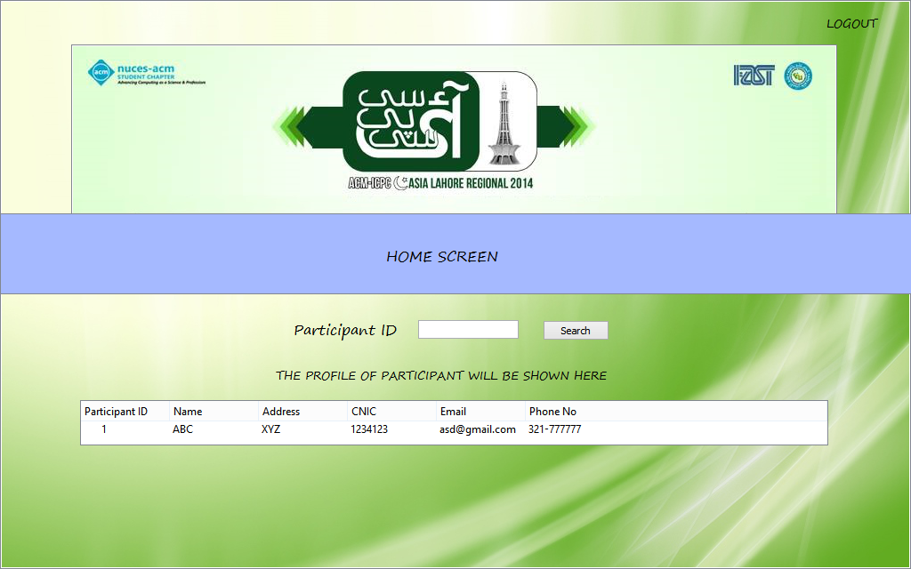

Error Message:

